
∑.E.M.
Releases notes v1.07

Releases notes
v1.06
Bugs & Change 4
Improvement 4
Campaign management #227 4
Improve form view for quality#235 5
Add order line / task / component link to NC #224 6
NC print document #251 6
Dashboard quality info #225 7
SVG viewer #252 7
Assign tasks and resources (without charges) #229 8
Display picture of service or ressources on tooltip #254 8
Create Gest page to follow quote or order statu #247 9
Add default Payment Conditions / Payment Methods / Delevery method #261 9
Opportunity page #228 10
Cheking link and display #262 10
Event log #264 11
Activity log #263 11
Time line #265 11
Try to put graph on tab #266 12
Display progress of each line #267 12
Display progress of order #269 12
Add label count in menu #271 13
Calculate the cost and price of tasks automatically upon entry #274 13
Only show companies with lines #282 13
Display delivery on invoice line #279 14
Check invoice #278 14
Display invoice statu on index list #277 14
Option to display requested order line only all task finiched #283 15
Check if order line task is in progress #281 15

Bugs & Change

#250 - 500 ERROR is occurred again on Method
#253 - No pagination on product list page
#257 - Call to undefined method ProtoneMedia\LaravelCrossEloquentSearch\Searcher::get()
#256 - Integrity constraint violation: 1048 Column 'campaign'
#270 - Fixe progress line
#285 - Event & Activities not filter with opp id
#286 - Cannot delete a status if it is active

Improvement

Campaign management #227
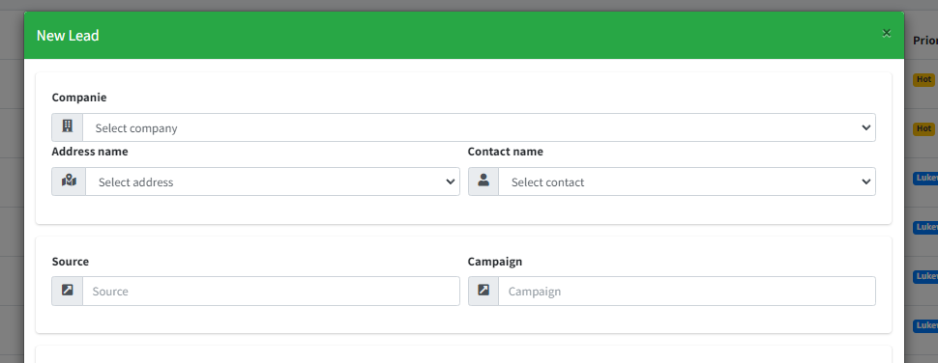

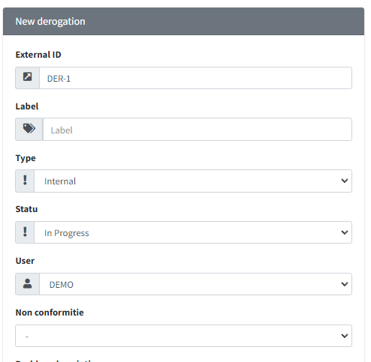
Improve form view for quality#235

Add order line / task / component link to NC #224
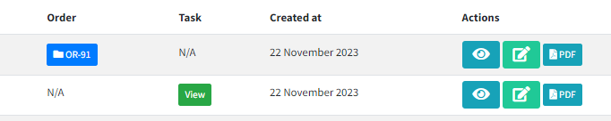

NC print document #251
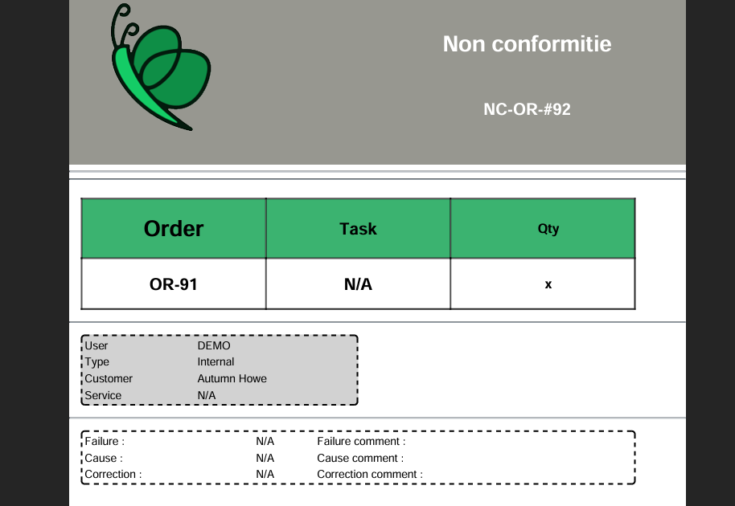

Dashboard quality info #225
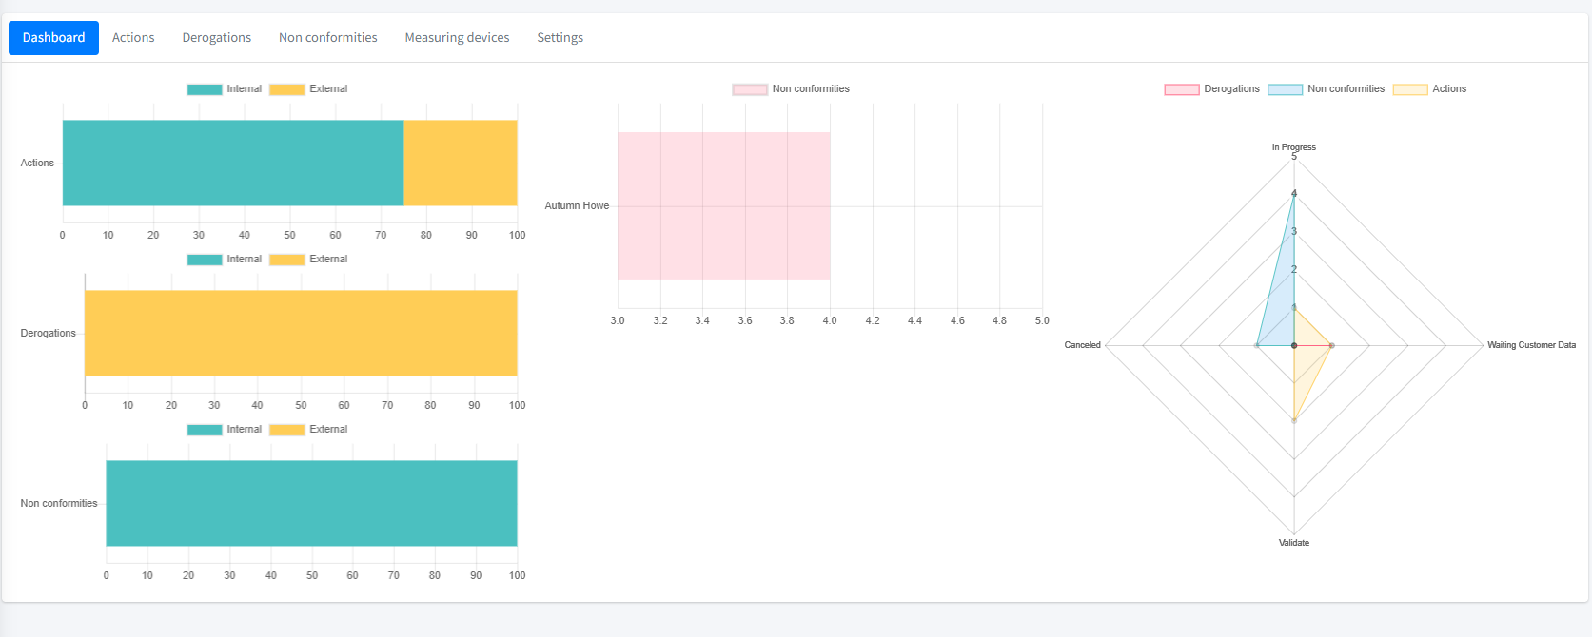

SVG viewer #252
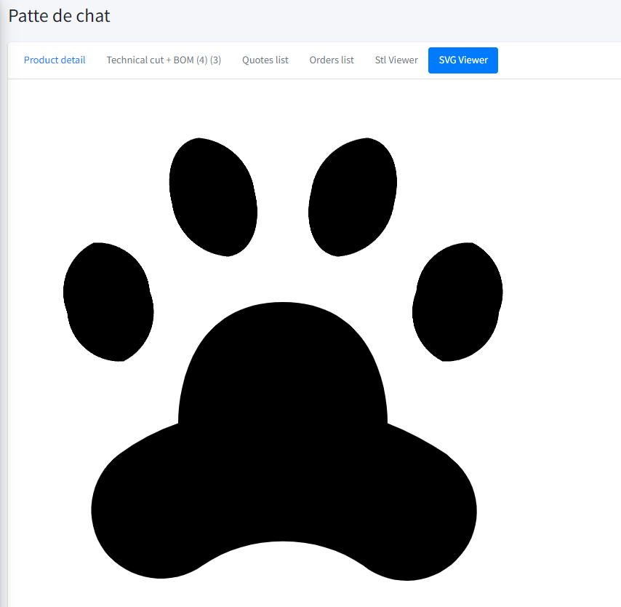

Assign tasks and resources (without charges) #229

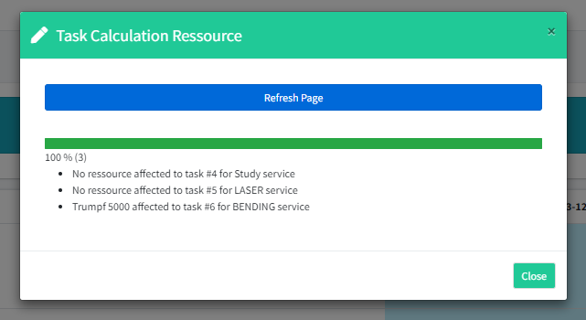

Display picture of service or ressources on tooltip #254

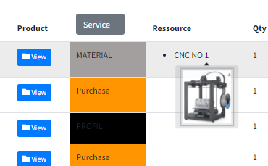

Create Gest page to follow quote or order statu #247
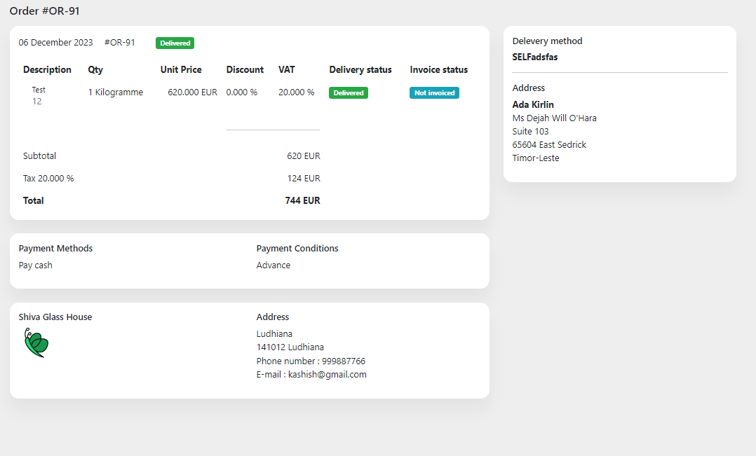

Add default Payment Conditions / Payment Methods / Delevery method #261
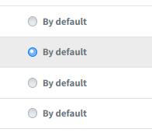

Opportunity page #228
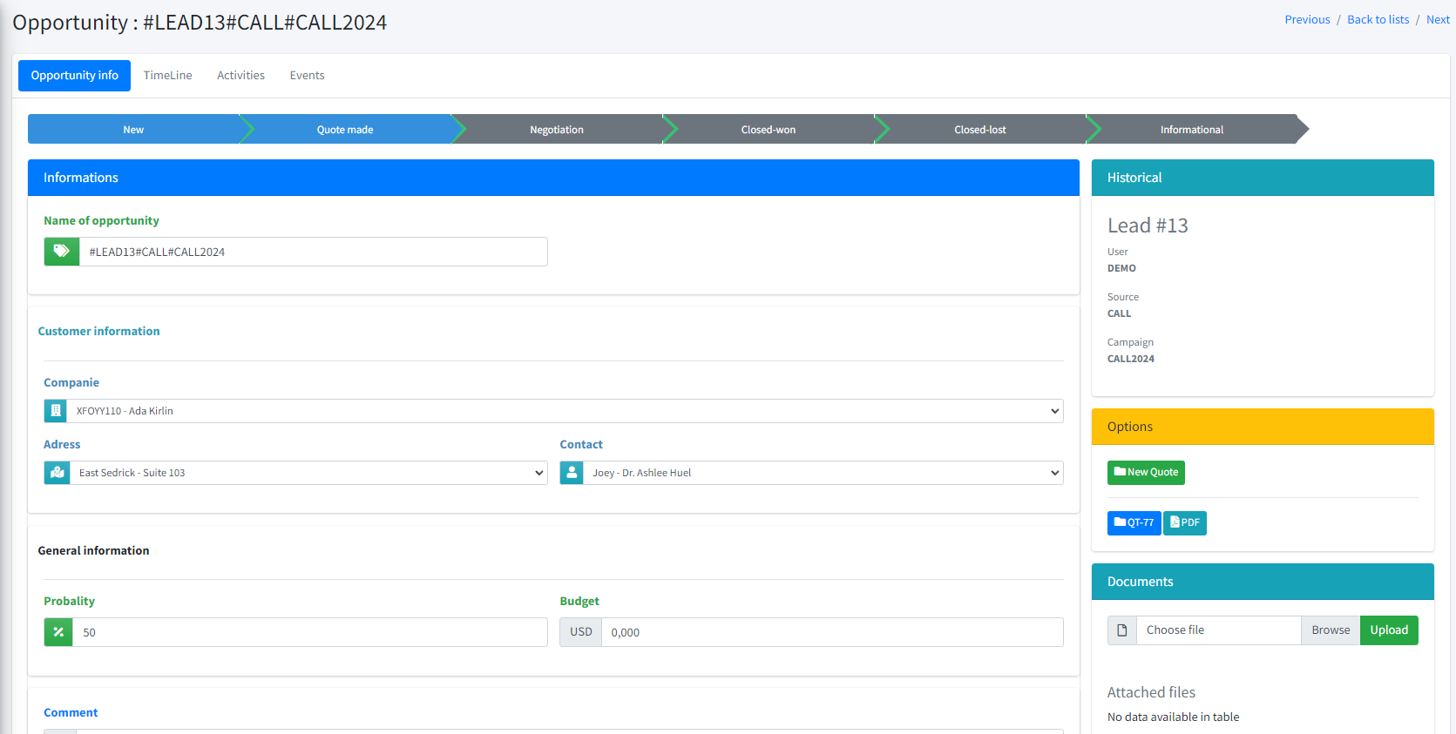

Cheking link and display #262
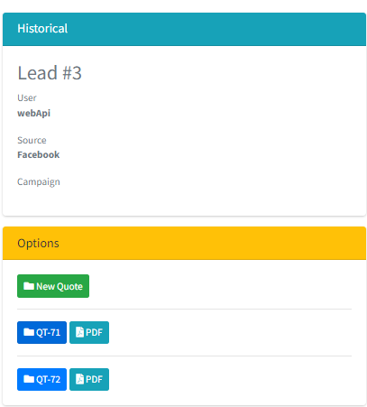

Event log #264
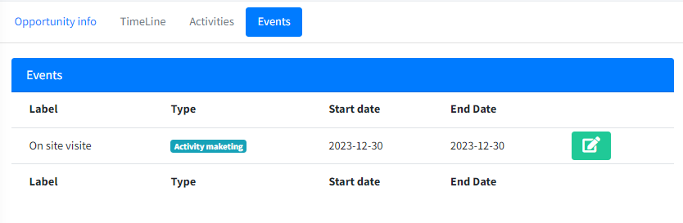

Activity log #263
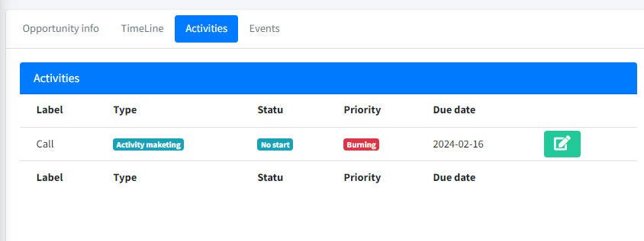

Time line #265
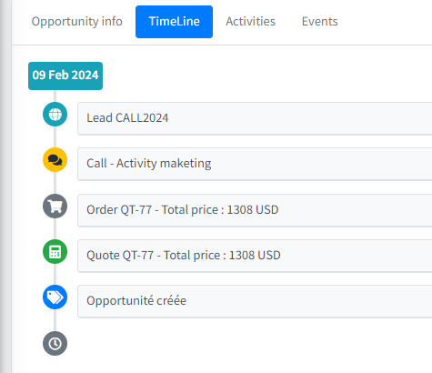

Try to put graph on tab #266
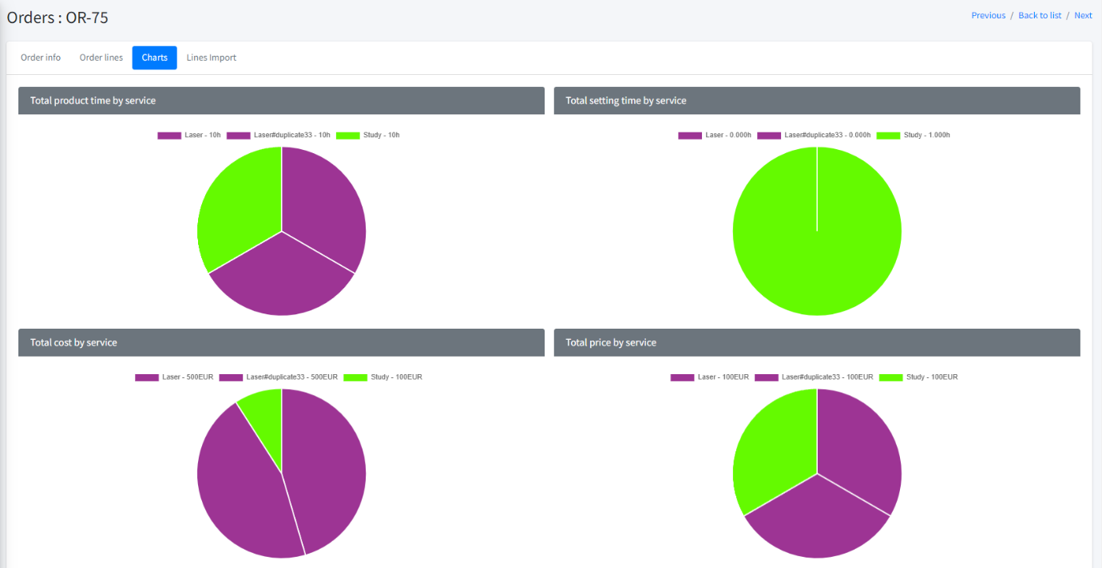

Display progress of each line #267
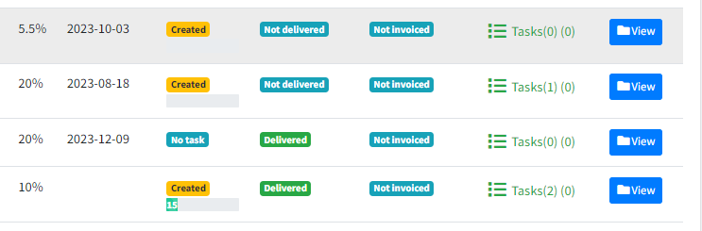

Display progress of order #269
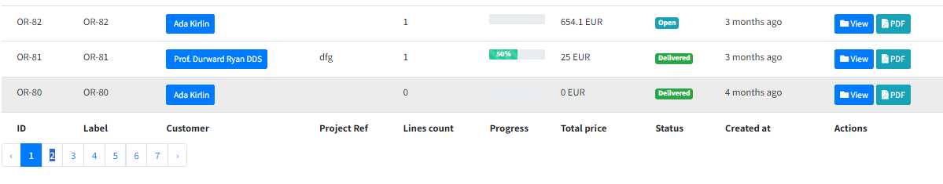

Add label count in menu #271
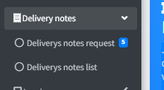

Calculate the cost and price of tasks automatically upon entry #274
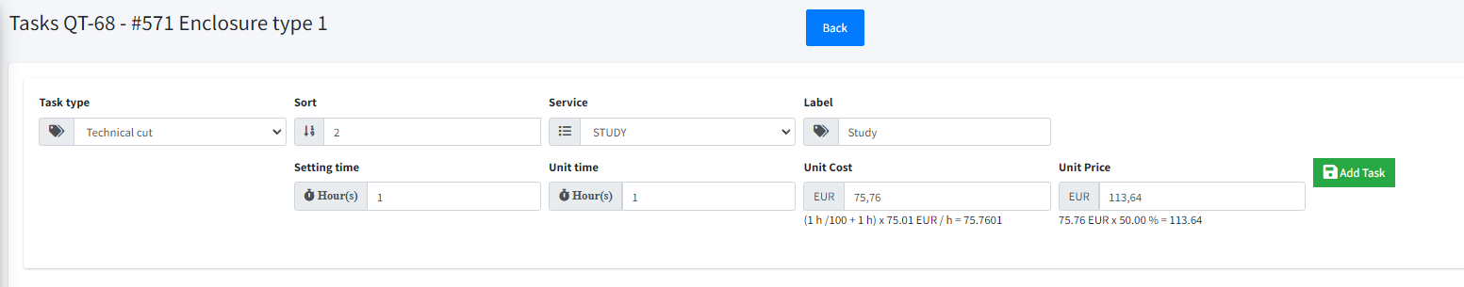

Only show companies with lines #282
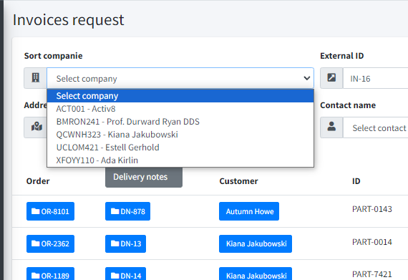

Display delivery on invoice line #279
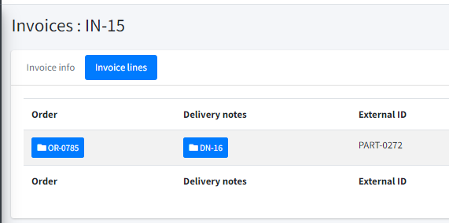

Check invoice #278
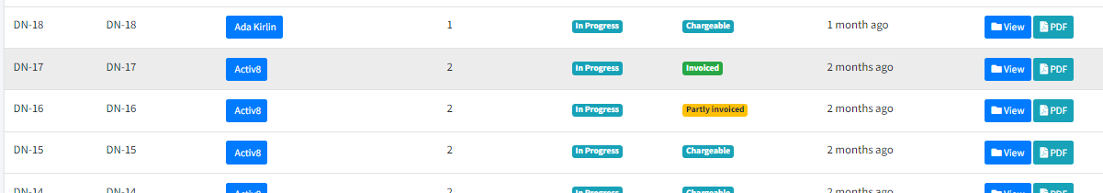

Display invoice statu on index list #277
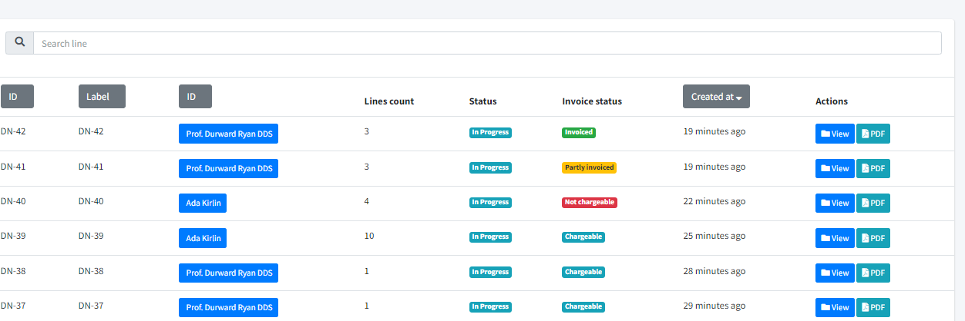

Option to display requested order line only all task finiched #283
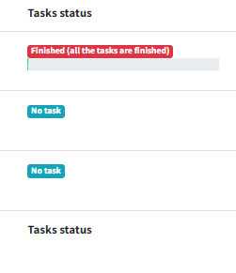

Check if order line task is in progress #281
